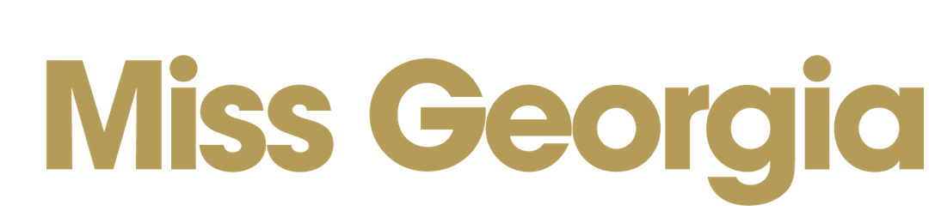
2022 Working Media Credential Request Form
Meet the Crowns Press Conference  3:00 p.m., Friday, June 10, 2022  Columbus Convention & Trade Center/Ironworks  801 Front Ave, Columbus, GA 31901 | MGSC Competition & Finals  Competition: June 15-17; Finals: Saturday, June 18  RiverCenter for the Performing Arts  900 Broadway, Columbus, GA 31091

≈ ≈ ≈ ≈ THIS FORM MUST BE RETURNED ASAP ≈ ≈ ≈ ≈
Please take a moment to fill out the form completely as this is essential to the credentialing process. This will allow us to plan accordingly and accommodate you properly during your visit to the MGSC. Credentials are issued only to working media. You will be notified by email if you are approved and next steps.
Media Outlet: | Click or tap here to enter text.
List the Name (contact name first) and Title of each person requesting credentials. Please be sure to indicate which day each person will be on-site. June 10th is the “Meet the Crowns” press conference, Prelims are 6/15-17; 6/18 is finals for both Miss Georgia and Miss Georgia’s Outstanding Teen.
 |  | Check Day(s) Someone is Working
Name | Role/Duty | Fri 6/10 | Wed  6/15 | Thurs  6/16 | Fri  6/17 | Sat  6/18
Click or tap here to enter text. | Click or tap here to enter text. | ☐ | ☐ | ☐ | ☐ | ☐
Click or tap here to enter text. | Click or tap here to enter text. | ☐ | ☐ | ☐ | ☐ | ☐
Click or tap here to enter text. | Click or tap here to enter text. | ☐ | ☐ | ☐ | ☐ | ☐
Please use additional forms if you needed. Details will be sent later as to how credentials will be provided.
Mailing address: | Click or tap here to enter text.
Email address: | Click or tap here to enter text.
Phone/Fax: | Click or tap here to enter text.
How can we make  your job easier? | Click or tap here to enter text.

NOTE: 1) ELECTRONIC MEDIA ALLOWED FOR NEWS COVERAGE ONLY. 2) Submitting this application does not guarantee approval for credentials. The MGSC reserves the right to not issue and/or revoke credentials from news organizations and/or representatives of the news organizations throughout the duration of the 2022 MGSC Competition at its sole discretion.
Return form by ASAP, to Rachel Crumbley at rmcrumbley@gmail.com.

